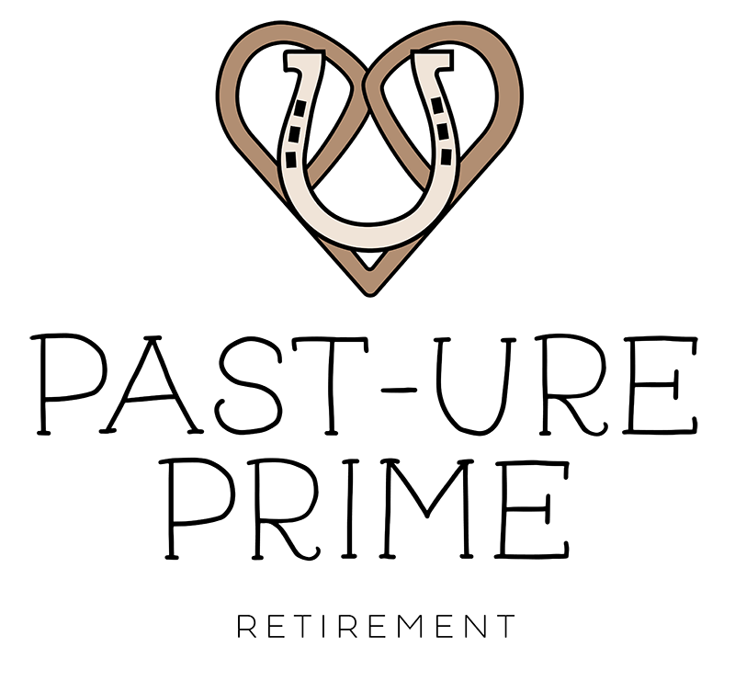

PASTURE BOARDING AGREEMENT
Honor and Glory Farm, LLC | Past-ure Prime Retirement

THIS AGREEMENT, for good and valuable consideration receipt of which is hereby acknowledged, is made by and between Honor and Glory Farm, LLC, hereinafter referred to as “STABLE,” and the undersigned party, hereinafter referred to as “OWNER.” These parties warrant that they have the right to enter into this AGREEMENT.

Date of Agreement: ___________________________

1. Owner Information
Owner Name:
Address:
Phone Number:.
Email Address:

2. Horse Information
Barn Name:
Show Name:
Breed:
Age:
Color:
Allergies / Vices:

3. Fees
In consideration of the current boarding rate paid by Owner for the selected board option, fees are due in advance by the 5th day of each month. If payment is received after the 5th, a late fee of $50.00 will be incurred. STABLE agrees to start boarding of said horse beginning on a month-to-month basis.

Board Type Selected:
□ Pasture Board □ Semi-Private Board □ Stall Board with Turnout
All partial month board will be pro-rated at the current daily rate of $20.00 per day for pasture board.

Beginning Date: .

4. Right of Lien
OWNER is put on notice that STABLE has and may assert and exercise a right of lien, as provided for by the laws of the State of Ohio, for any amount due for the board and keep of horse(s), and also for any storage or other charges due hereunder. OWNER further agrees STABLE shall have the right, without process of law, to attach a lien to your horse(s) after two (2) months of non-payment or partial payment, and STABLE can then sell horse(s) to recover its loss.

5. Standard of Care
It is agreed upon that the STABLE will provide normal and reasonable care to maintain the health and well-being of said horse. This includes scheduling of farrier services, scheduling of veterinary care, feeding of round bales/square bales free choice and as needed at the discretion of the STABLE, providing adequate shelter, graining as appropriate for each horse’s needs, and providing adequate water supply in pasture boarding lots. Special arrangements are at the discretion of STABLE. A stall can be rented in case of injury or necessity at the current daily rate. Annual vaccinations (if needed) are performed by our veterinarian.

6. In Case of Emergency
In case of an emergency veterinary need, STABLE has the right to call the primary veterinarian for STABLE. A copy of a current Coggins and vet records must be provided to STABLE prior to or upon arrival.

7. Stable Rules
Owner hereby acknowledges receipt and understanding of the current STABLE Rules, which are incorporated by reference in full as if fully set forth herein. OWNER agrees that he/she and his/her guests and invitees will be bound by and abide by these Rules, and accepts responsibility for the conduct of guests and invitees accordingly. STABLE may revise these Rules from time to time, and OWNER agrees any revision shall have the same force and effect as the current Rules. Failure, as determined in STABLE’s sole discretion, of OWNER or OWNER’s guests and invitees to abide by STABLE Rules may result in STABLE declaring OWNER in default and termination of this AGREEMENT. See attached rules document.

8. Risk of Loss
During the time that the horse(s) is/are in the custody of STABLE, STABLE shall not be liable for any sickness, disease, theft, death, or injury which may be suffered by the horse. This includes, but is not limited to, any personal injury or disability the horse may receive while on STABLE’s premises. OWNER fully understands and hereby acknowledges that STABLE does not carry any insurance on any horse(s) not owned by STABLE, including but not limited to such insurance for boarding or any other purposes. All risks relating to boarding of horse(s) or for any other reason for which the horse(s) is/are in the possession of STABLE are to be borne by OWNER.

Trailer parking service is available; per above, STABLE does not carry insurance on and shall not be held liable for any theft, weather, or other incidental damages to trailers. STABLE also has the right to move said trailer to another acceptable area on the property, but not to use it to transport horses or remove it from the farm.

9. Hold Harmless
Said OWNER agrees to hold harmless STABLE and Honor and Glory Farm, LLC, and all affiliated with said LLC, from any claim resulting from damage or injury caused by said horse to any person or other equines, and agrees to pay legal fees incurred by STABLE in defense of any such claim.

10. Equine Burial
Equine burial on the property is available at the current rate per horse. Honor and Glory Farm, LLC will provide a peaceful final resting place for your companion.

11. Termination
Either party may terminate this AGREEMENT for failure of the other party to meet any material terms of this AGREEMENT, including but not limited to Stable Rules. In the case of a default by one party, the other party shall have the right to recover legal fees and expenses, if any, incurred as a result of said default. Any payment due under this AGREEMENT shall be due and payable by the fifth day of the month and immediately in the event of termination. Failure to make any payment by said due date shall place OWNER in default hereunder. Acceptance by STABLE of any late payment shall not constitute a waiver of subsequent due dates or determinations of default.

SIGNATURES
By signing below, both parties agree to the terms set forth in this Agreement.

Horse Owner (OWNER)
Owner Signature: ________________________________________
Co-Owner Signature (if applicable): ________________________________________
Printed Name: ________________________________________
Date: ________________________________________

Thank you for trusting Past-ure Prime Retirement with the care of your horse.

